**Software Design and Architecture**



Lab # 05

Introduction to Java.

Instructor: Mazhar Iqbal

Email: mazhar.iqbal@nu.edu.pk

Course Code: CL2002

Semester Spring 2024

Department of Computer Science,

National University of Computer and Emerging Sciences FAST Peshawar Campus

# Java Introduction

Java is a programming language and a platform. Java is a high level, general purpose, robust, object-oriented and secure programming language, that is used to create variety of software.

Java was developed by *Sun Microsystems* (which is now the subsidiary of Oracle) in the year 1995. James Gosling is known as the father of Java.

# Java Application Types

According to Sun, 3 billion devices run Java. There are many devices where Java is currently used. Some of them are as follows:

* Desktop Applications such as acrobat reader, media player, antivirus, etc.
* Web Applications such as irctc.co.in, javatpoint.com, etc.
* Enterprise Applications such as banking applications.
* Mobile applications
* Embedded System
* Games, etc.

# Tools to be Used for Java Development

* Notepad and cmd
* IntelliJ Idea,NeatBeans or any other IDE.

# Java features

* Simple
* Object-Oriented
* Portable
* Platform independent
* Secured
* High Performance
* Multithreaded
* Distributed
* Dynamic

Robust etc**.**

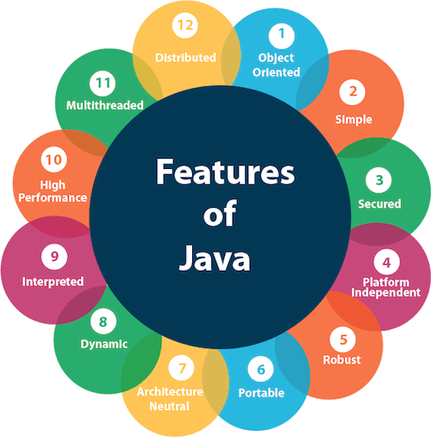

# How a Java Program runs?

# In Java, there is a special code known as Byte code. Byte Code can be defined as an intermediate code generated by the compiler after the compilation of source code (JAVA Program).

What is JVM?

# JVM (Java Virtual Machine) is an abstract machine that enables your computer to run a Java program.

# When you run the Java program, Java compiler first compiles your Java code to bytecode. Then, the JVM translates bytecode into native machine code (set of instructions that a computer's CPU executes directly).

# Java is a platform-independent language. It's because when you write Java code, it's ultimately written for JVM but not your physical machine (computer). Since JVM executes the Java bytecode which is platform-independent, Java is platform-independent.

# How does Java program work?

What is JRE?

JRE (Java Runtime Environment) is a software package that provides Java class libraries, Java Virtual Machine (JVM), and other components that are required to run Java applications.

JRE is the superset of JVM.

# JRE contains JVM and other Java class libraries.

# If you need to run Java programs, but not develop them, JRE is what you need.

What is JDK?

JDK (Java Development Kit) is a software development kit required to develop applications in Java. When you download JDK, JRE is also downloaded with it.

In addition to JRE, JDK also contains a number of development tools (compilers,



JavaDoc, Java Debugger, etc). Java Development Kit

# If you want to develop Java applications, download JDK.

Relationship between JVM, JRE, and JDK.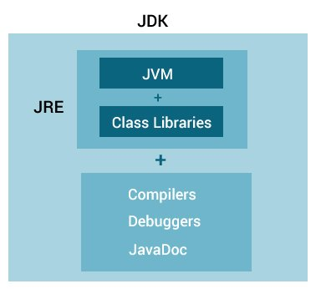

# IntelliJ IDEA Installation

IntelliJ IDEA is a cross-platform IDE that provides consistent experience on the Windows, macOS, and Linux operating systems.

IntelliJ IDEA is available in the following editions:

* Community Edition is free and open-source, licensed under Apache 2.0. It provides all the basic features for JVM and Android development.

# Navigate to <https://www.jetbrains.com/idea/download/#section=windows>

Download the community version of IntelliJ Idea.

# 

When the download is finished, click the exe file for installation, and then click next.

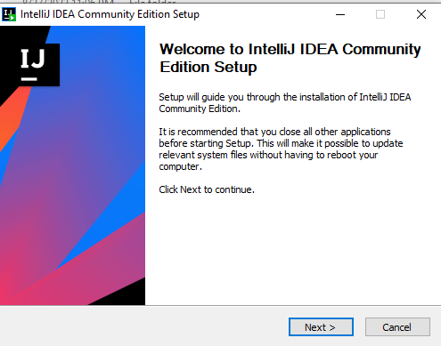

Choose a path for installation directory and then click Next.

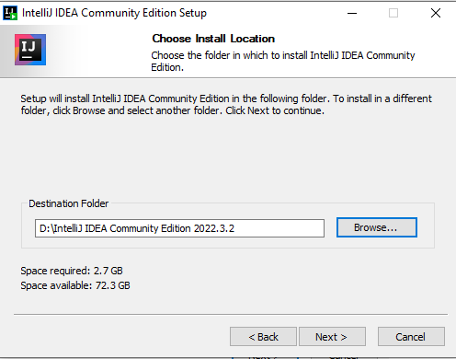

From the below options, click all the selected options and click Next.

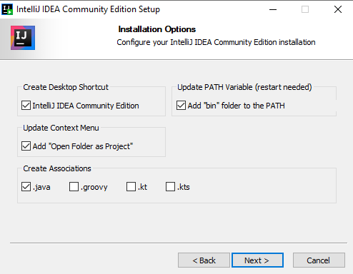

Click Install.

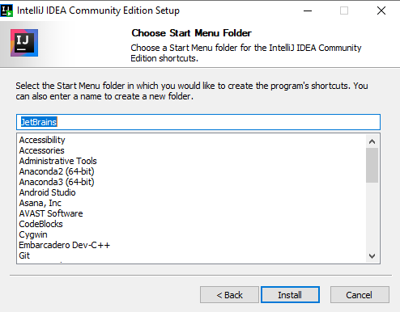

Click do not import settings.

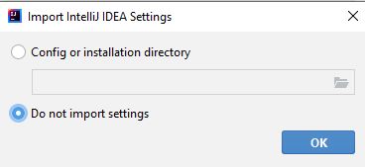

Click on the New Project.

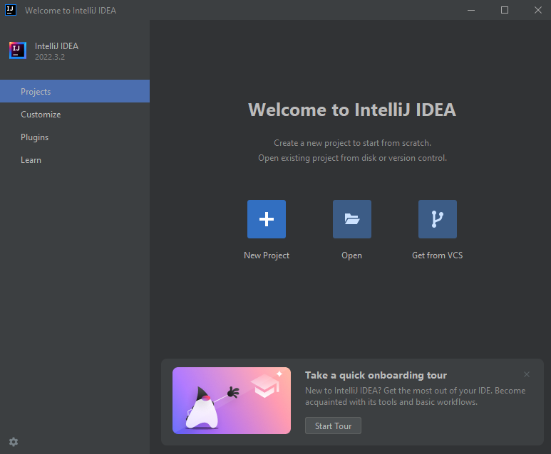

Now to develop a Java program, we need to install JDK. So, click on the download JDK option.

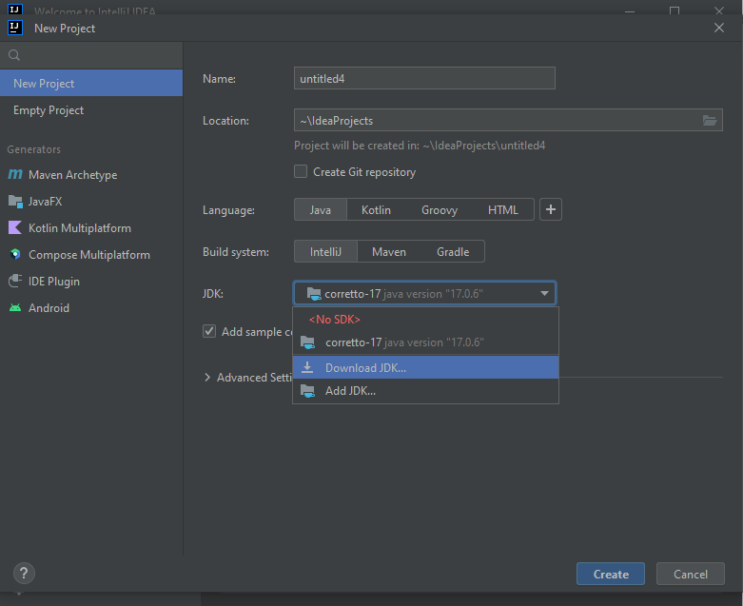

Although there are many JDK versions. Select JDK 11. And click on download.

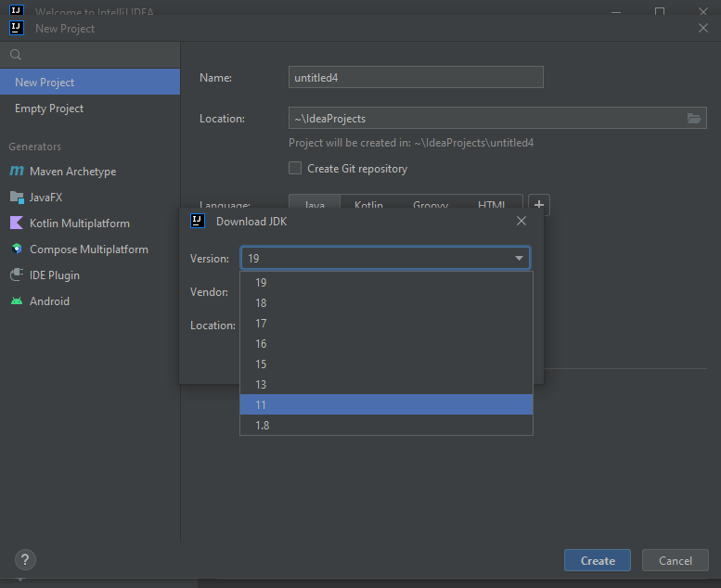

Then click on create.

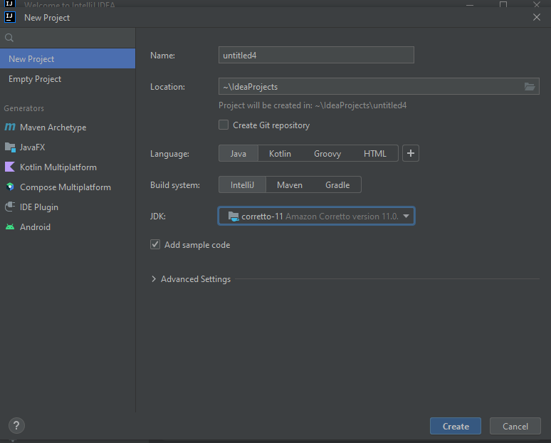

To add the path to your system, locate the JDK path, and copy it.

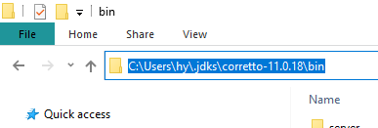

Go to environment variables, by searching it from the start menu. Click on environment variables.

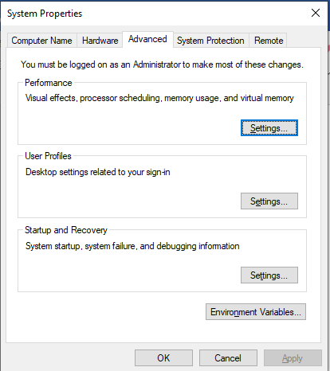

From the system variables, click Path.

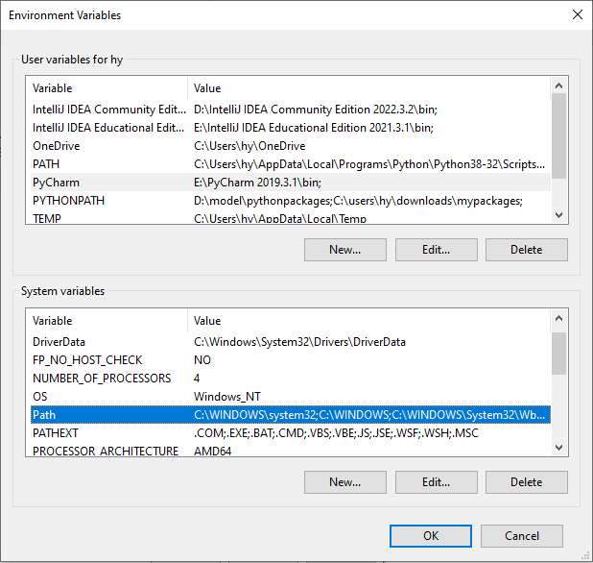

Click new to create a new path.

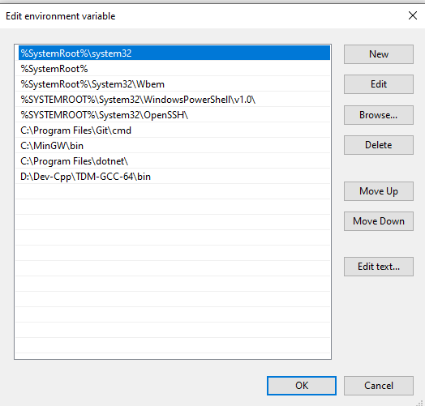

And then paste the path you copied. And hit OK.

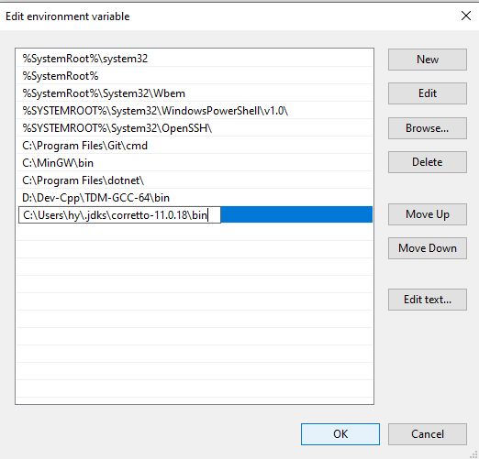

Now to check, if the path has been set or not, open CMD, type java, and press enter.